TRAINING OF FOREIGN CITIZENS AT THE BELARUSIAN STATE ACADEMY OF MUSIC

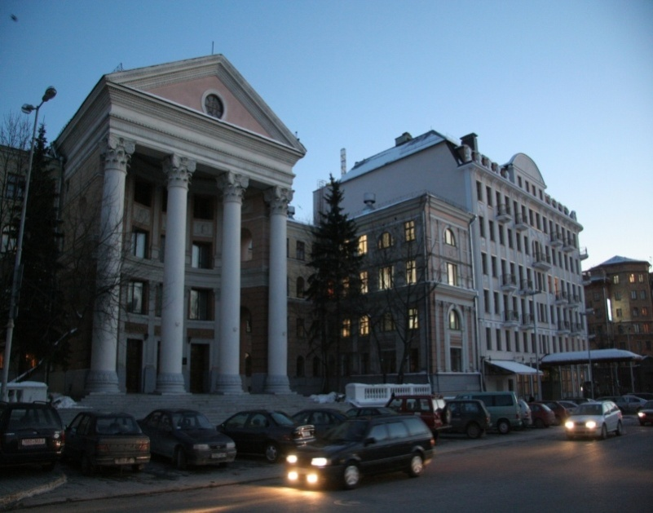

1. EDUCATIONAL PROGRAMS AND DURATION OF TRAINING
2. SPECIALITIES IN WHICH TRAINING OF FOREIGN CITIZENS IS CARRIED OUT. TUITION FEE
3. HOW TO APPLY TO THE BELARUSIAN STATE ACADEMY OF MUSIC
4. REQUIREMENTS TO PERFORMING A PROGRAM
5. HOW TO COME TO BELARUS?
6. AFTER ARRIVAL IN BELARUS
7. ACCOMMODATION
8. MARTICULATION TO THE 1ST AND 2ND STAGE OF HIGHER EDUCATION

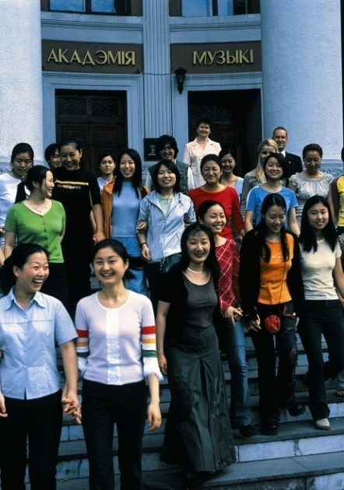

EDUCATIONAL PROGRAMS AND DURATION OF TRAINING

AT THE BELARUSIAN STATE ACEDEMY OF MUSIC

Educational Programs | Duration of training
Additional education for adults (PREPARATORY DEPARTMENT) | 9 months  From September 15 till June 15
1st stage of Higher education (BASIC COURSE) | 5 years  From September 1 till June 30
2nd stage of Higher education (MASTER’S DEGREE) | 1 year  From September 1 till June 30

Language of instruction – Russian.

Training in the English language is possible.

Training of foreign citizens at the Belarusian State Academy of Music is carried out on a FEE-PAYING basis.
IMPORTANT!!! Citizens of Russia, Kazakhstan, Kirgizstan and Tadzhikistan can apply to the Academy of Music and study on a fee-paying basis under the conditions prescribed for foreign citizens.

2. SPECIALITIES IN WHICH TRAINING OF FOREIGN CITIZENS IS CARRIED OUT. TUITION FEE

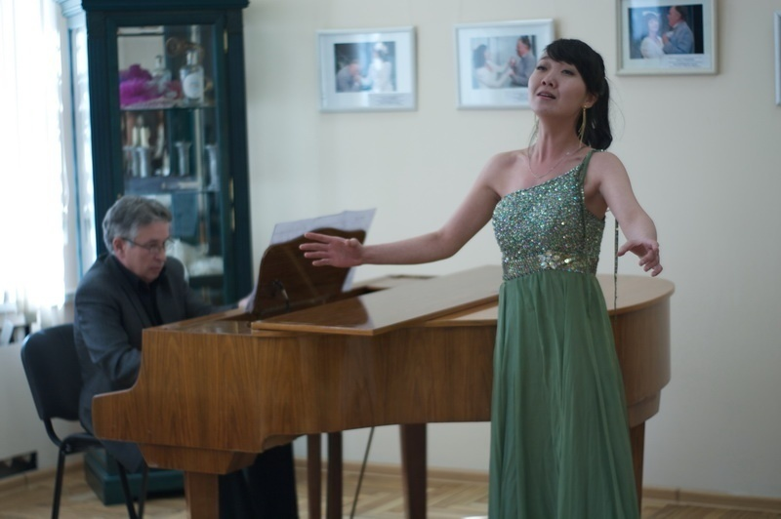

Educational Programs | Specialities, directions of speciality | Fee,  $ per year
Additional education for adults (PREPARATORY DEPARTMENT) | Speciality 1-16 01 01 Composition | 5 150
Speciality 1-16 01 02 Conducting (in directions)
Speciality direction:
1-16 01 02- 02 Conducting (academic choir)
 | Speciality 1-16 01 03 Piano
Speciality 1-16 01 04 String bow instruments (in directions)
Speciality directions:
1-16 01 04-01 String bow instruments (violin),
1- 16 01 04-02 String bow instruments (viola),
1-16 01 04-03 String bow instruments (cello),
1-16 01 04-04 String bow instruments (double-bass).
 | 1-16 01 05 Harp
Speciality 1-16 01 06 Wind instruments (in directions)
Speciality directions:
1-16 01 06-01 Wind instruments (flute),
1-16 01 06-02 Wind instruments (oboe),
1- 16 01 06-03 Wind instruments (clarinet),
1-16 01 06-04 Wind instruments (bassoon),
1-16 01 06-05 Wind instruments (horn),
1-16 01 06-06 Wind instruments (tuba),
1-16 01 06-07 Wind instruments (trombone),
1-16 01 06-08 Wind instruments (trumpet),
1-16 01 06-09 Wind instruments (baritone),
1- 16 01 06-10 Wind instruments (saxophone)
 | Speciality 1-16 01 07 Percussion instruments
Speciality 1-16 01 08 Plucked-String Percussion Folk Instruments (in directions)
Speciality directions:
1-16 01 08-01 Plucked-String Percussion Folk Instruments (guitar classical),
1-16 01 08-02 Plucked-String Percussion Folk Instruments (cimbalom),
1-16 01 08-03 Plucked-String Percussion Folk Instruments (balalaika),
1-16 01 08-04 Plucked-String Percussion Folk Instruments (domra)
 | Speciality 1-16 01 09 Bayan-accordion
Speciality 1-16 01 10 Singing (in directions)
Speciality direction:
1-16 01 10-01 Singing (academic)
Speciality1-17 02 01 Choreographic Art (in directions)
Speciality directions:
1-17 02 01-02 Choreographic Art (directing),
1-17 02 01- 03 Choreographic Art (pedagogy)
1st stage of Higher education (BASIC COURSE) | Speciality 1-16 01 01 Composition | 7 150
 | Speciality 1-16 01 02 Conducting (in directions)  Speciality directions:  1-16 01 02-02 Conducting (academic choir) | 6 850
 | Speciality 1-16 01 03 Piano | 7 250
 | Speciality 1-16 01 04 String bow instruments (in directions)  Speciality directions:  1-16 01 04-01 String bow instruments (violin),  1-16 01 04-02 String bow instruments (viola),  1-16 01 04-03 String bow instruments (cello),  1-16 01 04-04 String bow instruments (double-bass). | 7 250
 | Speciality 1-16 01 06 Wind instruments (in directions)  Speciality directions:  1-16 01 06-01 Wind instruments (flute),  1-16 01 06-02 Wind instruments (oboe),  1-16 01 06-03 Wind instruments (clarinet),  1-16 01 06-04 Wind instruments (bassoon),  1-16 01 06-05 Wind instruments (horn),  1-16 01 06-06 Wind instruments (tuba),  1-16 01 06-07 Wind instruments (trombone),  1-16 01 06-08 Wind instruments (trumpet),  1-16 01 06-09 Wind instruments (baritone),  1-16 01 06-10 Wind instruments (saxophone) | 7 050
 | Speciality 1-16 01 07 Percussion instruments | 7 150
 | Speciality 1-16 01 08 Plucked-String Percussion Folk Instruments (in directions)  Speciality directions:  1-16 01 08-01 Plucked-String Percussion Folk Instruments (guitar classical),  1-16 01 08-02 Plucked-String Percussion Folk Instruments (cimbalom),  1-16 01 08-03 Plucked-String Percussion Folk Instruments (balalaika),  1-16 01 08-04 Plucked-String Percussion Folk Instruments (domra) | 7 250
 | Speciality 1-16 01 09 Bayan-accordion | 7 250
 | Speciality 1-16 01 10 Singing (in directions)  Speciality direction:  1-16 01 10-01 Singing (academic) | 7 150
 | Speciality1-17 02 01 Choreographic Art (in directions)  Speciality directions:  1-17 02 01-02 Choreographic Art (directing),  1-17 02 01-03 Choreographic Art (pedagogy) | 7 050
 | 1-17 01 02-02 Theatre Directing (musical theatre) | 7 650
 | Speciality 1-21 04 02 Art History (in directions)  Speciality direction:  1-21 04 02-01 Art History (musicology) | 6 950
2nd stage of Higher education (MASTER’S DEGREE) | Speciality 1-16 80 01 Musical art | 7 550

3. HOW TO APPLY TO THE BELARUSIAN STATE ACADEMY OF MUSIC

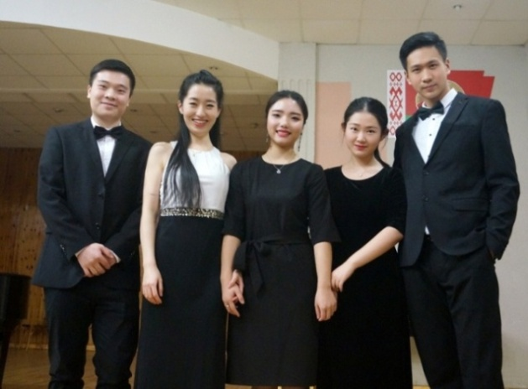

To get an invitation for study in the Republic of Belarus it requires submitting to the e-mail: international_st@bgam.by the electronic copies (scan) of all completed passport pages and link to the video recording on the website www.youtube.com
Submission of the documents for getting the invitation for study is held from April 01 to April 30.

TERMS OF THE ARRIVAL to study and personal submission of the documents to the Preparatory Department:
from August 23, 2021 to September 10, 2021

THE FOLLOWING DOCUMENTS MUST BE PROVIDED TO THE ADMISSION COMMITTEE:

- Application for admission to study in the prescribed form;
- The original of the certificate in education (document) with an indication of the studied subjects and the marks (points) obtained for them on exams;
- The conclusion of the medical advisory board issued by the territorial health organization of the Republic of Belarus (after passing a mandatory medical examination in the direction of the educational institution);
- Medical certificate of health status and certificate of absence of HIV infection, issued by the official health authority of the country from which the candidate came to study;
- Notarized copy of the birth certificate
- 6 photos, size 3x4 cm

The documents can be provided to the admission committee in person or through an intermediary with a notarized power of attorney.

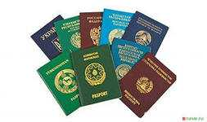 | 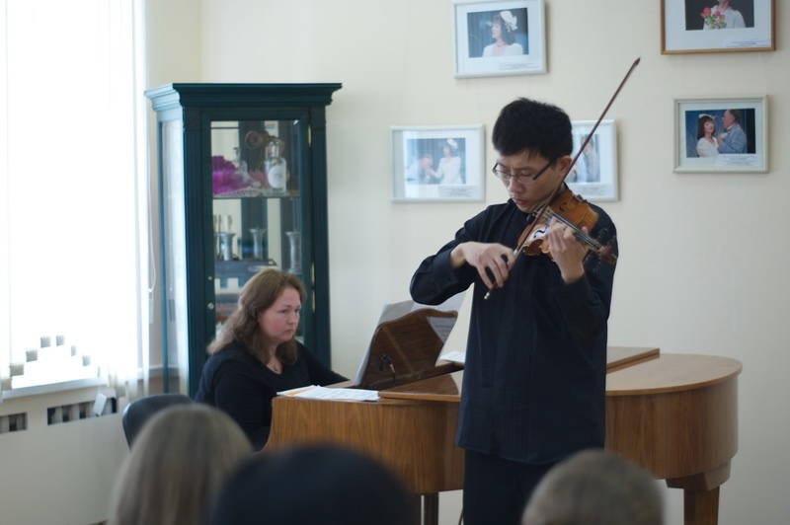

Auditions of applicants’ videos are held from May 4 to May 20.  Those applicants who successfully pass the audition will RECEIVE INVITATION for study. | 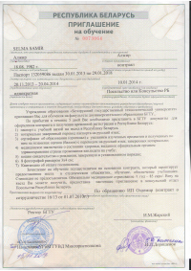

4. HOW TO COME TO BELARUS?

An educational visa is issued at the Consular Post of the Republic of Belarus at the place of residence. The requirements for documents can be different for countries and regions of the world, therefore, for detailed information on obtaining a visa in your region, please visit the website of the Ministry of Foreign Affairs of the Republic of Belarus (www.mfa.gov.by)

You can come to Belarus by air flight (we recommend BelAvia (www.belavia.by), Lufthansa, etc.) or by rail. Schedule of train traffic can be found on the website of the Belarusian Railway (www.rw.by).

Important!
You will receive medical insurance at the Academy of Music. Do not apply for insurance at the airport!

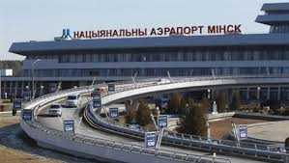

It is important to take into account the fact that the National Airport Minsk-2 is located 50 kilometers from the city of Minsk. You can be delivered to the center of Minsk by taxi ($30) or by regular bus ($3).

Regular buses No. 300E and 173E, fixed-route taxis No. 1400-ТК, No. 1430-ТК run from the Minsk National Airport to the city of Minsk. Bus and minibus timetables can be viewed here: http://airport.by/transport/regular-route-bus

In case of an independent visit to Minsk, it is necessary to inform the Foreign Students Sector of the Academy of the time of arrival in advance by calling +375 (17) 321 21 97 or e-mail: international_st@bgam.by

In addition, you need to obtain information about the location of the dormitory in which you have a reserved place in advance. Dormitory workers give a coming student a room key and necessary supplies. It is advisable to check into the dormitory during working hours from 9:00 to 17:00 (Minsk time).

5. AFTER ARRIVAL IN BELARUS

WITHIN 3 DAYS you have to come to the Foreign Students Sector of the Academy (Minsk, 30 Internatsionalnaya St, room No. 126) for official registration of papers.
IT IS REQUIRED TO:
- provide a passport and an educational visa;
2. provide original documents;
3. provide a medical certificate, certificate of absence of HIV infection;
4. conclude an agreement and pay for training;
5. obtain a compulsory health insurance policy;
6. provide 4 photos (4 x 6);
7. For registration with the Citizenship and Migration Authorities, provide the documents:
  - passport;
  - translation of the passport into Russian, certified by a public notary;
  - medical insurance;
  - payment receipt of the state fee for the registration;
  - PCR test for nucleic acid.
8. Pass a medical examination at Student Clinic No.33.

Foreign citizens pay all medical insurance expenses by themselves.
6. ACCOMMODATION

All foreign citizens studying at the Belarusian State Academy of Music are provided with a comfortable block-type dormitory. Accommodation – together with Belarusian students in rooms of two or four people each.
The cost of living in the dormitory is about $50 per month.

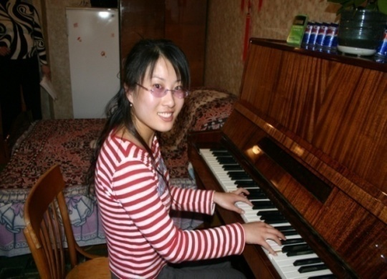

7. MATRICULATION TO THE 1ST AND 2ND STAGE OF HIGHER EDUCATION

Marticulation to the 1st and 2nd stage of Higher education is carried out only after satisfactory passing of the final exams in the Russian language, speciality and theory of music at the Preparatory Department. Students who unsatisfactorily completed the Preparatory Department curriculum may be offered a second year of study on the same conditions.

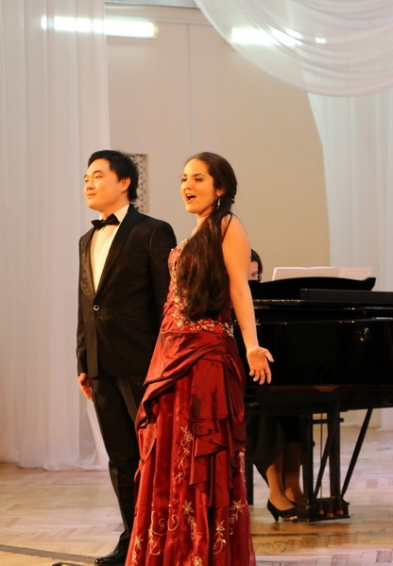
Contact information:
Education Institution “Belarusian State Academy of Music”
30 Internatsionalnaya Street
220030, Minsk, Belarus
Phone: (375-17) 321 21 97
Fax: (375-17) 328 55 01
E-mail: international_st@bgam.by
Leading Specialist for Work with Foreign Students
Liubov Alekseena Khmelevskaya

